MVCC Elder Reaffirmation
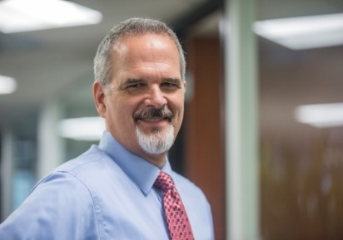

Mark Seits
Mark has been married to his beautiful wife, Mary, for over 40 years. They have 3 girls and 2 boys, ranging from age 19 to 33. Their oldest, Brittany, finished her Master’s Degree in Bassoon Performance at USC and is the Associate Dean for Undergrad Admissions at USC’s Thornton School of Music. Their daughter Hannah has a graduate degree in Speech Pathology and works in the Special Needs Program at Ramona High School. She just got married last year and is due to give Mark and Mary their first grandchild in June. Their oldest son, Jered, is a glazier and has picked up dad’s love for playing softball. Blake is finishing up his MBA and playing basketball at CSU San Marcos. Their youngest, Grace, is in her junior year at LSU majoring in Kinesiology and playing beach volleyball. She also wants to work with special needs kids.
Mark and his family moved to Ramona in 2006 and have fully adapted to the ‘R Town’ lifestyle. Mark is a Civil Engineer, specializing in flood control and water resources engineering. Now empty nesters (when the kids aren’t home from college) and nearing retirement, Mark is looking forward to pursuing his passion for golf and Mary can’t wait to check off more books to read and knitting patterns for the baby.
Mark accepted Jesus Christ as his Lord and Savior in 1989. The Seits have been attending MVCC since 2007 and became official members in 2012. Mark is currently serving as Chair of the Elder Board. Mark has served in numerous leadership roles in other churches, including Men’s Ministry Leader and Head Usher. Mark and Mary both attend Ron Hardesty’s Wednesday night Life Group. If reaffirmed as an Elder, Mark is looking forward to using his leadership and administrative gifts to continue to help the body of Christ at MVCC, as well as all of Ramona and beyond, become a Community of Christ-followers who live and love like Jesus.
MVCC Elder Reaffirmation

Mark Seits
Mark has been married to his beautiful wife, Mary, for over 40 years. They have 3 girls and 2 boys, ranging from age 19 to 33. Their oldest, Brittany, finished her Master’s Degree in Bassoon Performance at USC and is the Associate Dean for Undergrad Admissions at USC’s Thornton School of Music. Their daughter Hannah has a graduate degree in Speech Pathology and works in the Special Needs Program at Ramona High School. She just got married last year and is due to give Mark and Mary their first grandchild in June. Their oldest son, Jered, is a glazier and has picked up dad’s love for playing softball. Blake is finishing up his MBA and playing basketball at CSU San Marcos. Their youngest, Grace, is in her junior year at LSU majoring in Kinesiology and playing beach volleyball. She also wants to work with special needs kids.
Mark and his family moved to Ramona in 2006 and have fully adapted to the ‘R Town’ lifestyle. Mark is a Civil Engineer, specializing in flood control and water resources engineering. Now empty nesters (when the kids aren’t home from college) and nearing retirement, Mark is looking forward to pursuing his passion for golf and Mary can’t wait to check off more books to read and knitting patterns for the baby.
Mark accepted Jesus Christ as his Lord and Savior in 1989. The Seits have been attending MVCC since 2007 and became official members in 2012. Mark is currently serving as Chair of the Elder Board. Mark has served in numerous leadership roles in other churches, including Men’s Ministry Leader and Head Usher. Mark and Mary both attend Ron Hardesty’s Wednesday night Life Group. If reaffirmed as an Elder, Mark is looking forward to using his leadership and administrative gifts to continue to help the body of Christ at MVCC, as well as all of Ramona and beyond, become a Community of Christ-followers who live and love like Jesus.

